**Rive, Richard (Moore) (1931 – 1989)**

Molly Hall, University of Rhode Island

**[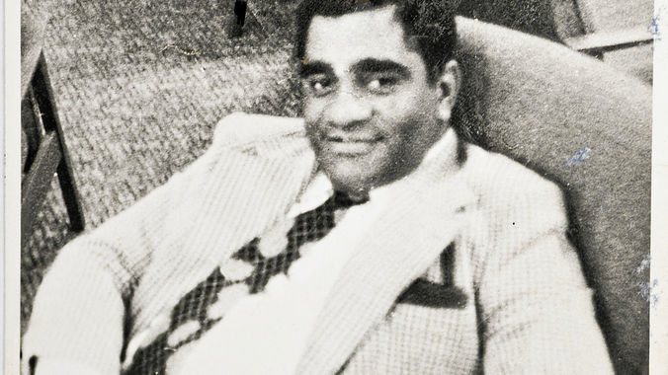](http://mg.co.za/article/2013-10-04-00-richard-rive-biography-wheres-the-roistering-braggart)Rive, in Shaun Viljoen’s Biography of Rive**

(url: http://mg.co.za/article/2013-10-04-00-richard-rive-biography-wheres-the-roistering-braggart)

Born March 1, 1931 in Cape Town, South African author Richard Rive was a novelist, editor, short story writer, and critic. Rive grew up in a ‘coloured’ working class area of Cape Town called District Six, a segregated area he later wrote about in his widely acclaimed novel, ‘*Buckingham Palace,’ District Six* (1986). Rive himself was ‘coloured,’ which in South African lexicon refers to a specific interracial identity particular to the area and distinct from Black Africans, considered to be a sort of creolization of various African, white, and indigenous ethnicities. His father, an African-American ship-hand named Richardson Moore, left him and his ‘coloured’ mother a few months after his birth, never to be seen again. Because the Afrikaner government required all people during Apartheid to be racially categorized, he too was considered ‘coloured’ like his mother. Race later became the central concern of his writing.

Intellectually gifted from a young age, he won scholarships to all the best schools in his District. After high school he trained at an educational college to teach, then, while working as a high school English teacher and director of athletics at a local school, he completed his BA at the University of Cape Town over the course of a decade. In the early 1960s he decided to pursue advanced degrees: a Master’s at Columbia University and then a doctorate in English on a Fulbright scholarship, which he earned in 1974, completing his thesis on Olive Schreiner, a fellow South African writer. His critical work on her was published after his death as *Olive Schreiner: Letters: 1871-1899* (1988). Before going abroad for education, he was the editor for *Drum* magazine in the 1950s and connected with many fellow anti-Apartheid artists such as Jack Cope, Ingrid Jonker, Jan Rabie, Marjorie Wallace, Es’kia Mphahlele and Nadine Gordimer. He held several guest lecturer and visiting professor positions over the years at institutions such as Harvard, and was the head of the English department at his own Hewat College of Education, training the next generation of South African English teachers while continuing to write himself.

While he could have continued a fruitful career outside his homeland, he chose to return to South Africa and build a life there, believing he could best fight against racism by staying there, while many others fled, too frustrated or disgusted by government policy to remain. All three of his most prominent novels were banned by the government for their anti-Apartheid stance. In 2013 he was honored posthumously for his contributions to the fight against Apartheid at the Aziz Hassim Literary Awards in Durban, South Africa. One of his most famous stories, from *African Songs* (1963), ‘The Bench,’ resets the story of African-American civil rights activist Rosa Parks in South Africa, and characterizing his typical style, combining the imaginative use of leitmotifs with his signature realistic yet didactic dialogue. Thematically, most of his writing dealt with the degradation of life in the less privileged districts and both the ironic and oppressive nature of living under Apartheid, such as his first novel *Emergency* (1964), which takes place during the Sharpeville Massacre and attendant State of Emergency in 1960.

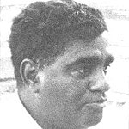**Rive, Public Domain**

(url: http://www.sahistory.org.za/people/richard-rive)

Though those who knew him respected him, many found him arrogant and stand-offish. While his over-confidence defined his public self, privately, he is thought to have struggled deeply with his own racial and sexual identity, about which he was said to be often defensive. Rive was murdered in his own home, stabbed to death by two young men for reasons some believe were related to his homosexuality—not yet accepted in South African society—but others say resulted from a robbery gone bad, in early June of 1989.

**Selected List of Works**

Collected Works

Selected Writings (1977)

Novels

*Emergency* (1964)

*Advance, Retreat* (1983)

‘*Buckingham Palace,’ District Six* (1986)

*Emergency Continued* (1991)

Short Story Collections

African Songs (1963)

Autobiographical Writings

*Writing Black:* An Author’s Notebook(1981)

Posthumous Publications

*Olive Schreiner: Letters: 1871-1899* (1988)

Edited Works

*Quartet:* New Voices from South Africa (1963)

*Modern African Prose* (1964)

**Further Reading**

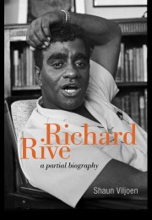

**Rive, Book Cover, Viljoen Biography**

(url: http://witspress.co.za/catalogue/richard-rive-2/)

Davis, Geoffrey V. (2003) [*Voices of Justice and Reason*](http://books.google.co.uk/books?id=m0bgeQPQXu4C&pg=PA95&lpg=PA95&dq=%22Richard+Rive%22&source=web&ots=MZFjY-gEDh&sig=dFR6vx_6HHehZvXxxt0gI5U8J7c&hl=en&sa=X&oi=book_result&resnum=5&ct=result), Rodopi.

Gikandi*,* Simon (2009) *The Routledge Encyclopedia of African Literature,* London: Routledge.

Lindfors, Bernth and Reinhard Sander (1993) *Twentieth-Century Caribbean and Black African Writers*, Detroit: Gale Research.

Viljoen, Shaun (2013) *Richard Rive: A Partial Biography*, Johannesburg: Wits University Press.